Direct Deposit for RSO Reimbursements:

Sign up for Direct Deposit to receive your reimbursement faster, safer and directly into your bank account.  Using Direct Deposit will ensure your reimbursement is received safely, securely and in a timely manner.  It is also very easy to set-up:

MyWSU ->Main Menu ->Self Service->Campus Finances-> Enroll in Direct Deposit. There are three types of direct deposit at WSU, Payroll, Travel and Student. They need to be enrolled in Travel to get RSO reimbursements.

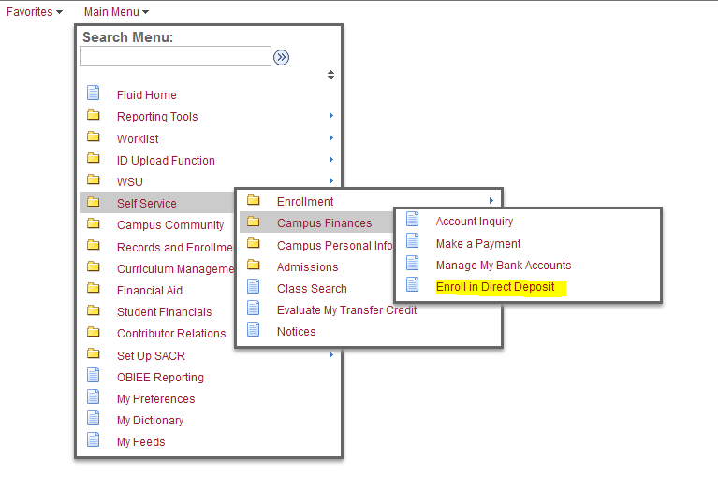

Once you are done the Direct Deposit will be active and you can receive your money directly into your bank account.

For any questions about Direct Deposit please contact [RSO.Help@wsu.edu](mailto:RSO.Help@wsu.edu) or

call 509-335-1085.